Step 1
Mount all components in Sch. “Power”.
Test that the correct voltages on voltage rails are being produced. LEDs should light up. Use test points near LEDs for easy measurement.

Step 2
Mount all components in Sch. “Amplifier”. Also mount coaxial connectors J1 and J4, and resistor R1 (located on first page of schematics). Test the amplifier by connecting an oscilloscope with a bandwidth greater than 350MHz to J4 (oscilloscope input must be terminated in >>50ohm), and plug a signal generator with bandwidth greater than 350MHz to J1. The input signal must be a negative square pulse with maximum negative amplitude of 10mV and length of 150ns. Greater values than 30mV can damage the amplifier. The output of the amplifier should look as follows:

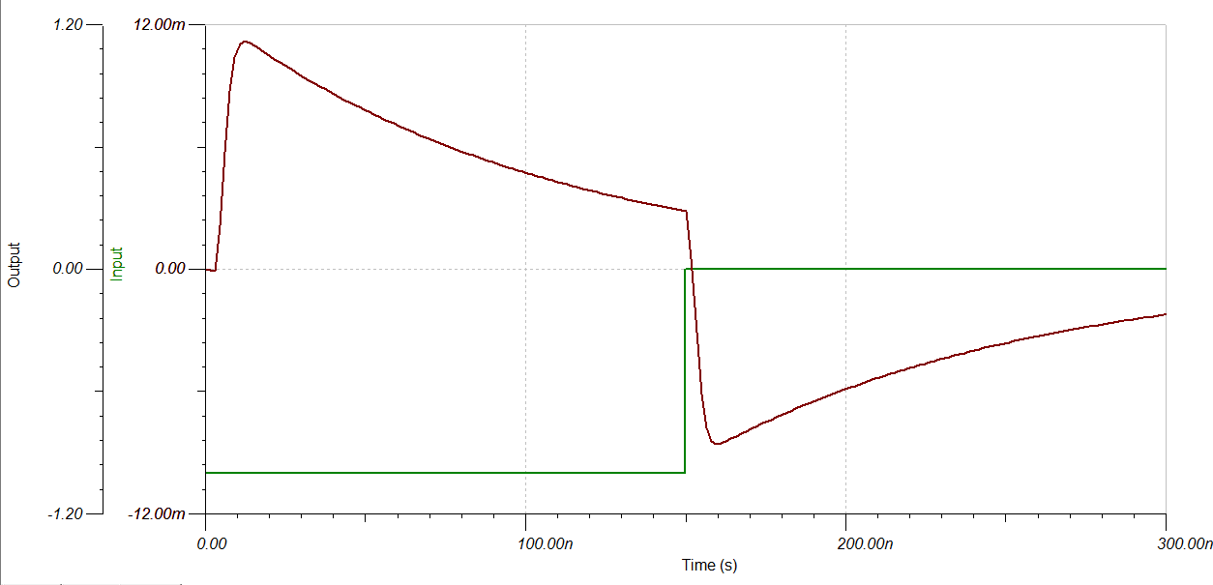
Measure the noise spectrum of the amplifier output with nothing connected to the input coaxial connector. Contact me (Magne Lauritzen, room 50B 5239, melauritzen@lbl.gov) at this point so I can verify that it is behaving as expected.

Step 3:
On Sch. “Discriminator”, mount components in block labeled “level threshold adjust”. Verify that the discriminator threshold adjuster works by adjusting RV1 and monitoring the output of U7. It should go from 0V to 3V. Mount blocks labelled “protection” and apply the same -10mV input signal to the amplifier while measuring the amplifier output as in step 2. It should look as follows:

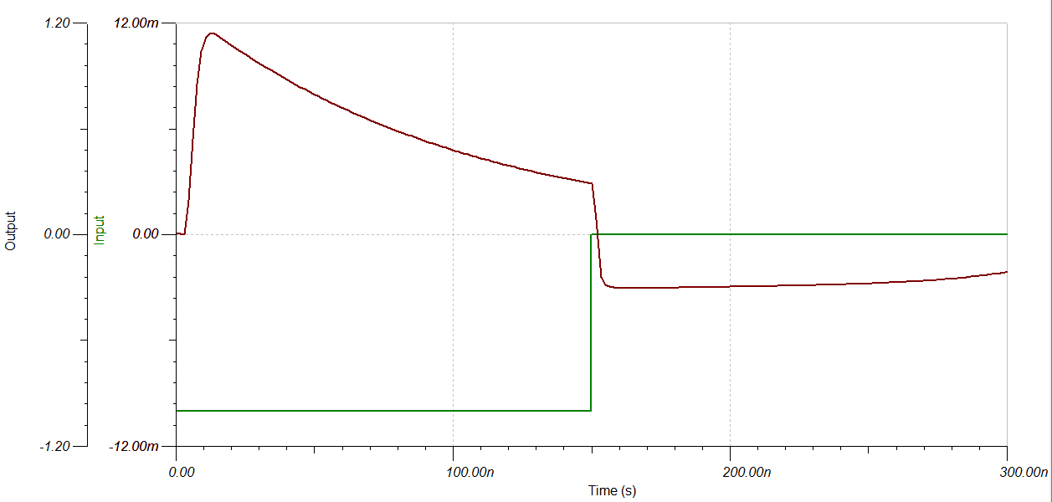
Mount the blocks labelled“discriminator” and “termination”. Verify that the discriminator works by doing the following:
    - Adjust the discriminator threshold to around 600mV.
    - Insert the -10mV square pulse on the amplifier input as you did when testing the amplifier.
    - Monitor the positive discriminator output (Q, pin 6). It should go from 1.6V to 2.4V (or thereabouts) when the input signal is above 600mV.
Mount the components in the blocks named “Output”. Test the outputs by repeating the previous steps 1-2 while monitoring TTL_OUT and the two LVDS_OUT pins.
Mount the components in the block “Timer”. Test that it works by doing the following:
    - Apply a short (10-50ns) -10mV square pulse on the amplifier input while monitoring the TTL_OUT pin.
    - Adjust the potentiometer RV2. The length of the output pulse should vary accordingly.

Step 4:
If everything has gone well until now, mount all the other components on the board.

